Brute Force Attack
- Objective:
To demonstrate how brute force assaults can be launched against a Windows system using Kali Linux (Hydra), followed by an analysis of security logs to identify the attack.

- Overview:
Set up a test environment with Kali Linux as the attacker using Hydra to perform brute-force login attempts on a Windows system, then review Windows security logs to observe how such attacks appear.
- Lab Requirements:
- Kali Linux
- Windows 10/Windows Server
- Both Attack Machine and Target Machine on same network

- Step-by-Step:
Step 1: Verify Target RDP Service
- Power on the target machine Open Server Manager Local Server
- Check Remote Desktop = Enable

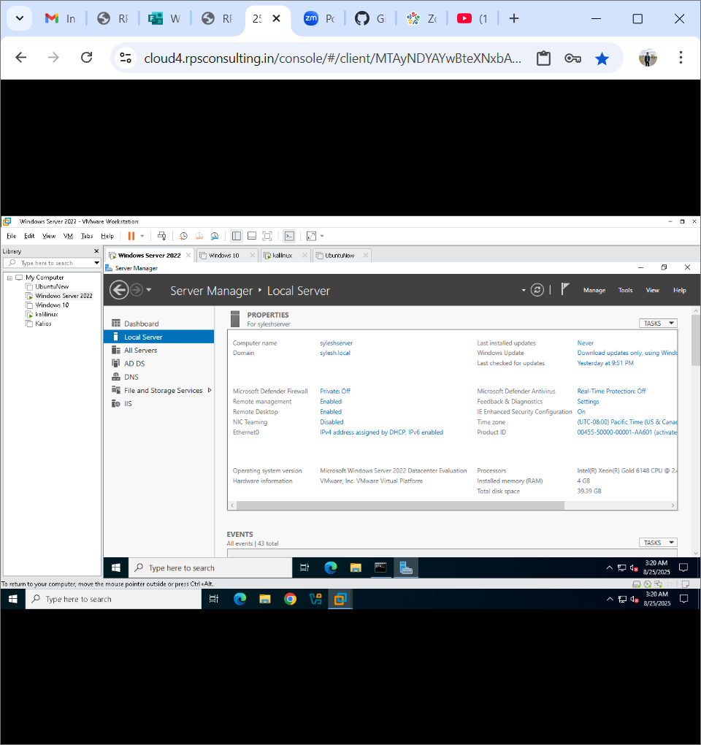
Step 2: Verify the port 3389 is open or not using the Nmap
- nmap -p 3389 <TargetIP>

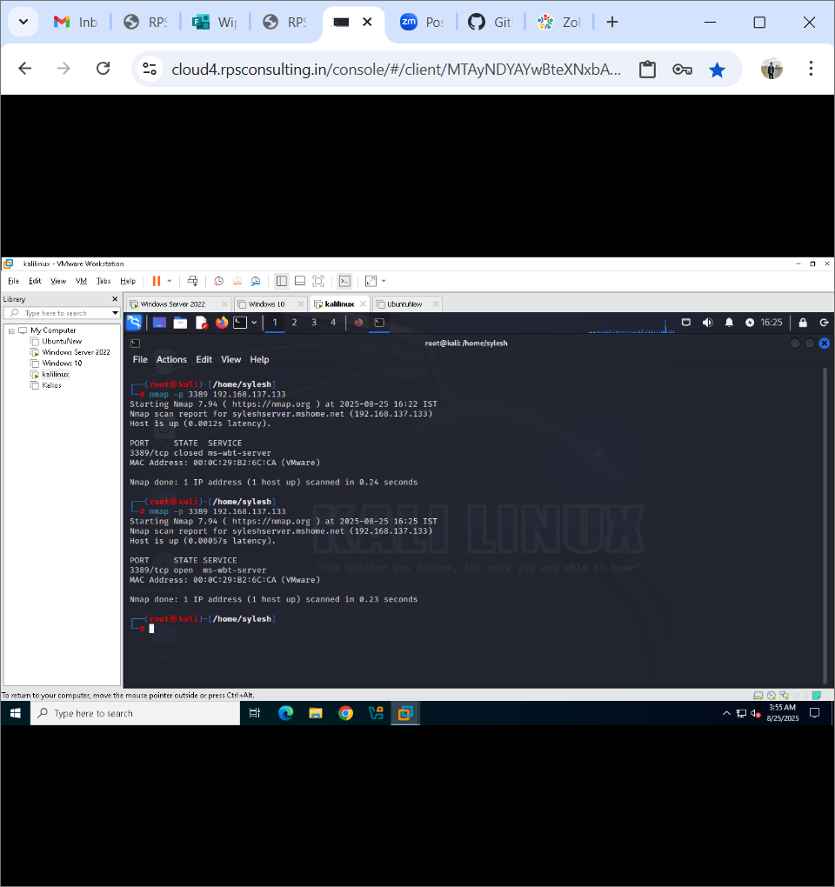

Step 3: Let Us Attack
- Create a simple Password list in kali (anyname.txt)
- echo “12345” > pass.txt
- echo “password” >>pass.txt
- echo “your real password” >> pass.txt
- Or you can use nano pass.txt command

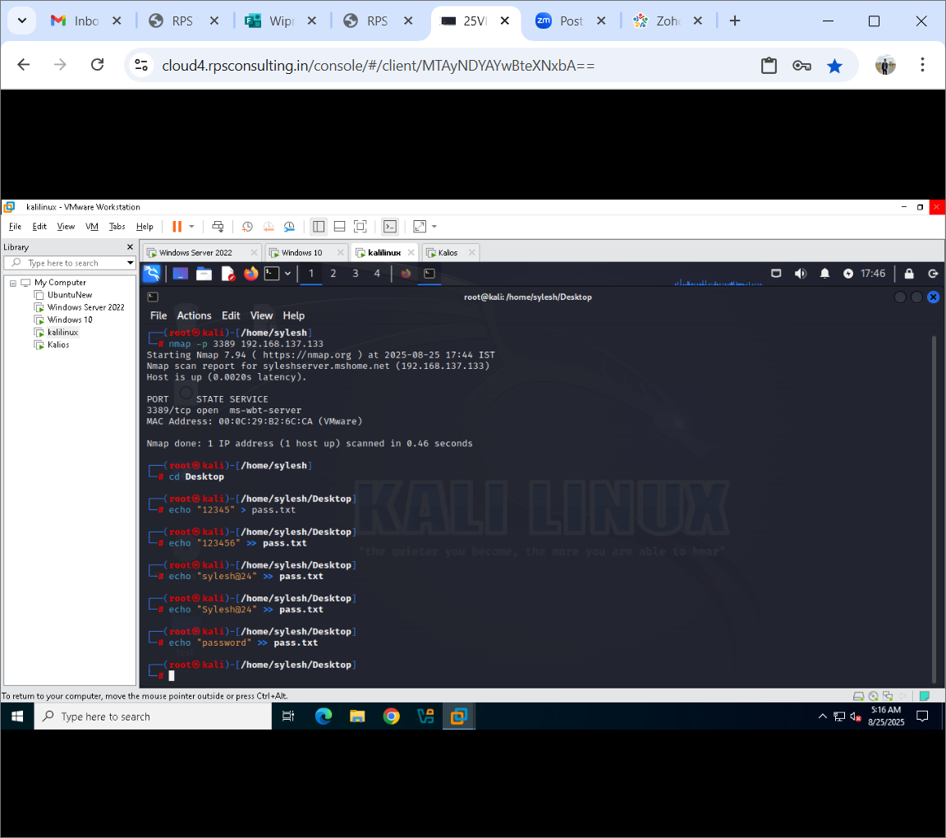

Step 4: Run Hydra against the RDP Service
- hydra -t 1 -l administrator -p pass.txt rdp://target_ip

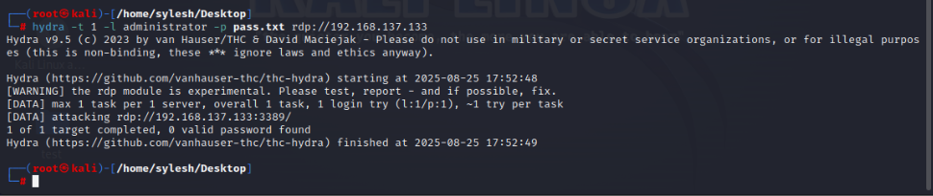

Step 5: Let us observe the Attack using Event Viewer
- On the Windows Server, open Event Viewer → Windows Logs → Security.
- Look for the following events:
  - Event ID 4625 → Failed login attempts (multiple, from Kali IP).
  - Event ID 4624 → Successful login once Hydra finds the right password.
- These entries represent the failed login attempts made by Hydra using incorrect credentials.
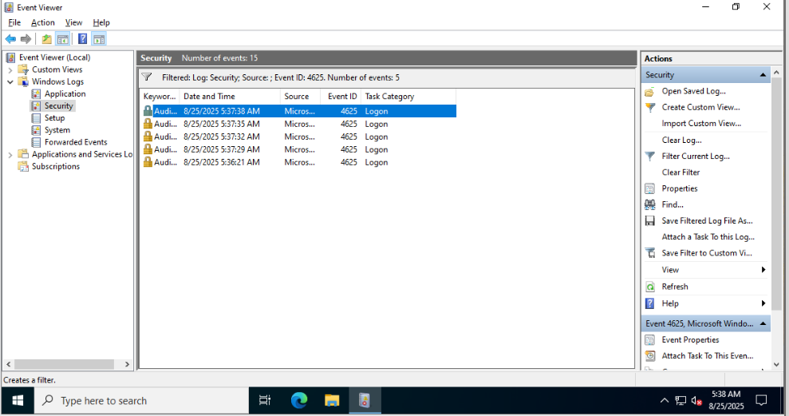

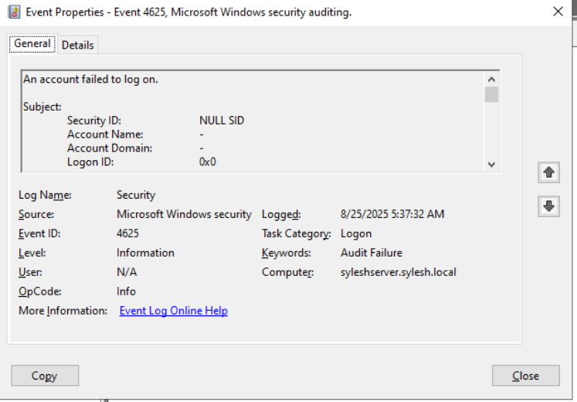
- This entry indicates the successful login where Hydra used the correct credentials.

